Book Club Titles for 2023

Jan.9th A Tale of Two Biddies by Kylie Logan ~ Sharon
Feb.13th The Maid by Nita Prose ~ Connie G.
Mar.13th Run, Rose Run by James Patterson/Dolly Parton~ Connie K.
Apr.10th Midnight at the Blackbird Café by Heather Webber~ Stacey
May.8th The Keeper of Lost Things by Ruth Hogan ~ Stacey
Jun.12th Seabreeze Inn by Jan Moran ~ Stacey
July 10th Sweet Tea and Sympathy by Molly Harper~ Stacey
Aug.14th The Judges List by John Grisham ~Connie K.
Sept.11th Revenge of Innocents by Nancy Taylor Rosenberg ~Stacey*
Oct. 9th The Shack by William P. Young ~ Connie K.
Nov.13th Tuesdays with Morrie by Mitch Albom~ Stacey*
Dec. 11th A Christmas themed book of your choice 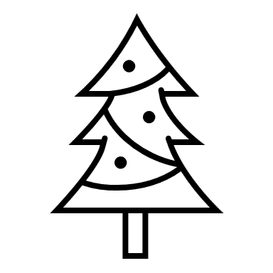

*NORWELD book discussion book

